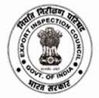
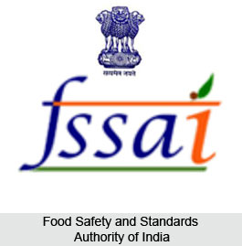
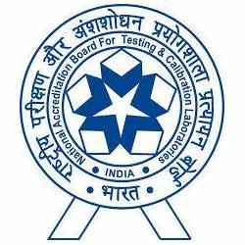

Awareness program of NABL for State laboratories to enable NABL accreditation
By
Food Safety and Standards Authority of India
In collaboration with
EIC and NABL for the Western Region, in Mumbai
23rd February 2017
Application Form
- Name:
- Date of Birth:
- Sex: Male/Female:
- Designation:
- Present Employer address:
- Correspondence address:
E-mail:
Mobile:
- Educational Qualification:
- Work Experience in analytical Field: ( ) years
S.No | Name of Organization | Field of Work | Period
S.No | Name of Organization | Field of Work | From | To

Date:
Place: Signature of the applicant
Recommendation of the forwarding Authority
Date:
Signature
Name & Designation

